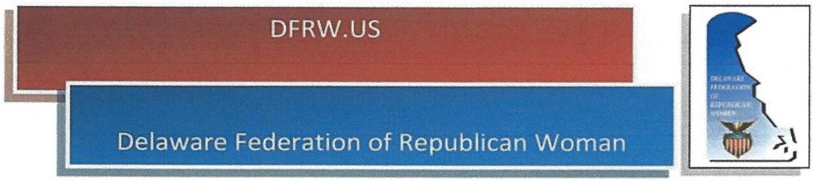
I______________________________________________ {Person or Business) wish to support the
DFRW's 2020 Annual Convention, Celebrating the 19th Amendment Centennial -- Road to the Future, with a:
SPONSORSHIP
___ PLATINUM @ $500 - which includes a full page color ad in the program and 4 convention tickets.
___ GOLD @ $250 - which includes a full page color ad in the program with 2 convention tickets.
___ SILVER @ $100 - which includes a half page color ad in the program and 1 convention ticket.
COLOR PROGRAM ADS

___ Full page at $100
___ Half page at $50

___ Quarter page (business card) at $25
___ One line listing of your name as a patron - $10
Patron Name _

Program pages are 5 ½ inches wide by 8 ½ inches tall. Please email your ad copy in Publisher, Word, or as a high-resolution JPEG file to Gale White. Ads emailed in PDF format will be scanned. Business cards can be used for half or quarter page ads. Business cards and other hard copy can be mailed to Gale and will be scanned. Ad copy and payment must be received no later than November 5, 2020. If you have any questions about layout or artwork, contact:
Gale White, 39 Gainsborough Drive, Lewes, DE 19958
302.644.0777 or galegwhite@comcast.net
Please provide contact person, email and phone:_______________________________________________ _
Checks, payable to DFRW, should be mailed to Gale White at address above.
Thank you very much for your support.

